THE FUTURE
Tugboats are the workhorses of the waterways. Almost everyone has seen one, either in books, or traversing the canal, but few have experienced a tugboat first hand. The John Arthur will continue to be involved in community events and functions where the general public has the opportunity to hear her story and witness working history for themselves.
As an interactive display, the John Arthur’s many features, including the Atlas Imperial engine, utilitarian living accommodations, and stark wheelhouse, allow all visitors a first hand understanding of life on a tugboat. Since she is not a static display, the crew will always have new and interesting stories to tell of the trip to whatever location she finds herself. The John Arthur is not a live-aboard boat but a preserved workboat still in work clothes.
With Chesapeake City as her homeport, the John Arthur is positioned well to participate in regional events and actively seeks new opportunities to engage the public.
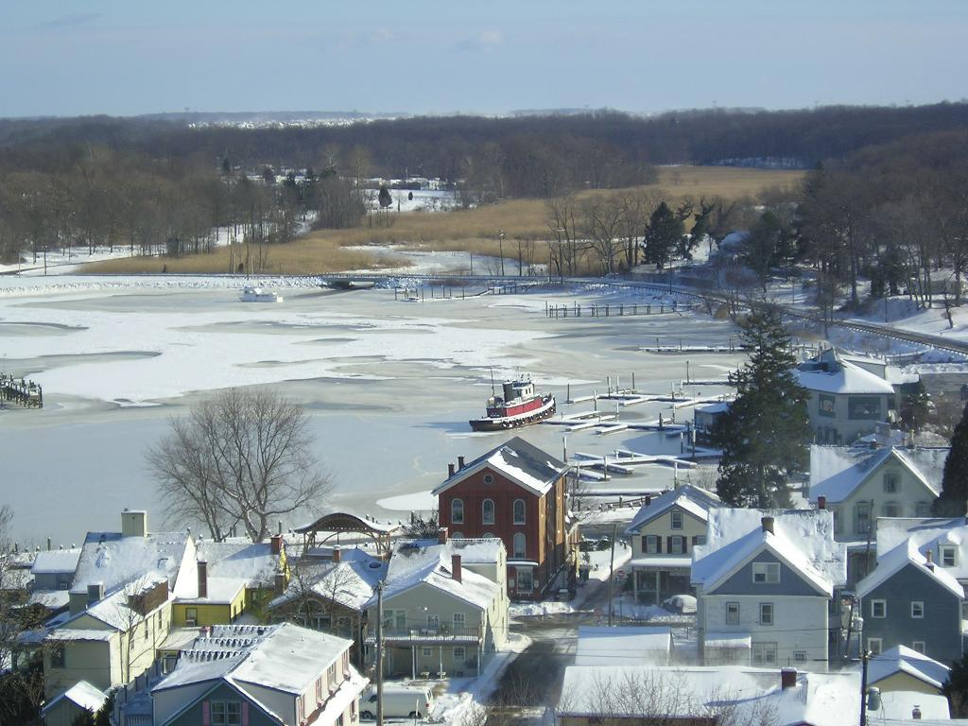

STATISTICS
YEAR BUILT: 1942
LENGTH: 65.5 feet
BREADTH: 18.0 feet
DEPTH OF HULL: 9.2 feet
WATER DRAFT: 7 feet light
AIR DRAFT: 36.2 feet light
Gross Tonnes: 80
Net Tonnes: 32
DISPLACEMENT: 115 tons

TOURS INFO
Currently tours are given by appointment. Scheduled tours are being organized so please check the website or contact George Coates for more information. If you see the John Arthur, please stop to say “Hello”.

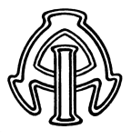

Tug John Arthur
Captain George Coates
Chesapeake City, Maryland 21921
Phone (410)620-0215
www.tugjohnarthur.com
The Tug
John Arthur

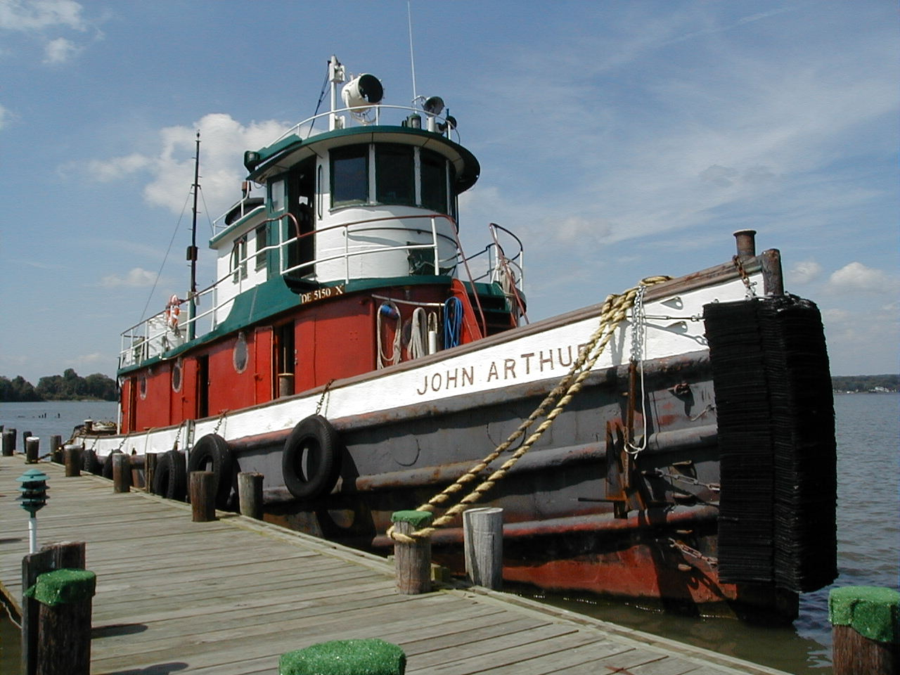

Captain George Coates
410-620-0215
302-598-9954
Chesapeake City, Maryland

History
The 70 foot tug John Arthur was built in Port Arthur, Texas in 1942 and still retains her original Atlas Imperial diesel engine that was erected in 1939 in Oakland, California. The tug worked the Gulf Coast most of the time with trips as far west as Galveston and as far north as St. Paul. Maximum crew was 11 men, with 9 being common. When the engine control was changed to Pilot House control, the crew was reduced to 6 men. The John Arthur was considered obsolete and retired from service in the mid 1970’s.
The Atlas Imperial is the first common rail, direct injection engine offered in the United States. In an attempt to improve economy and performance Atlas developed an electronic injection system using vacuum tubes in 1929 but abandoned the system when the tubes proved much too fragile for use near a diesel engine. Weighing 52,000 pounds, it is an air start, direct reversing 6 cylinder engine developing 400 HP at 300 RPM with a bore of 13 inches and a 16 inch stroke displacing about 7.3 cubic feet and producing 7,000 pound feet of torque. This engine uses about 10 gallons of fuel every hour at 9 miles per hour and the John Arthur has tankage for 6,000 gallons of fuel.
.

HER STORY
In 1942, John Arthur’s keel was laid for $1.00. Eight months later, delivery cost was $380,000. Attesting to her work, the lien was released in less than five years. She is built strong and with the Atlas Imperial, dependability was never a question.
In the early 1960’s, after 20 years of service, she went through her first major overhaul. AC power with updated generators, hydraulic steering, and wheelhouse control were some of the improvements made at this time.
She worked another fifteen years and was retired from service.
In October 2002, the John Arthur lay derelict and forgotten. Her paint was faded, steel rusted, and she was listing from rain water. The old Atlas was destined for scrap.
Rescued from this fate, the John Arthur made its way from a forgotten backwater bayou and into the hearts of the people of the Chesapeake Bay. Today she enjoys her retirement attending various events around the Bay. Where-ever the John Arthur goes people of all ages enjoy dockside tours and talks. Most folks have never been close to a tugboat and relish the idea of actually walking through a tugboat so rich in history.

EVENTS

Calvert Marine Museum
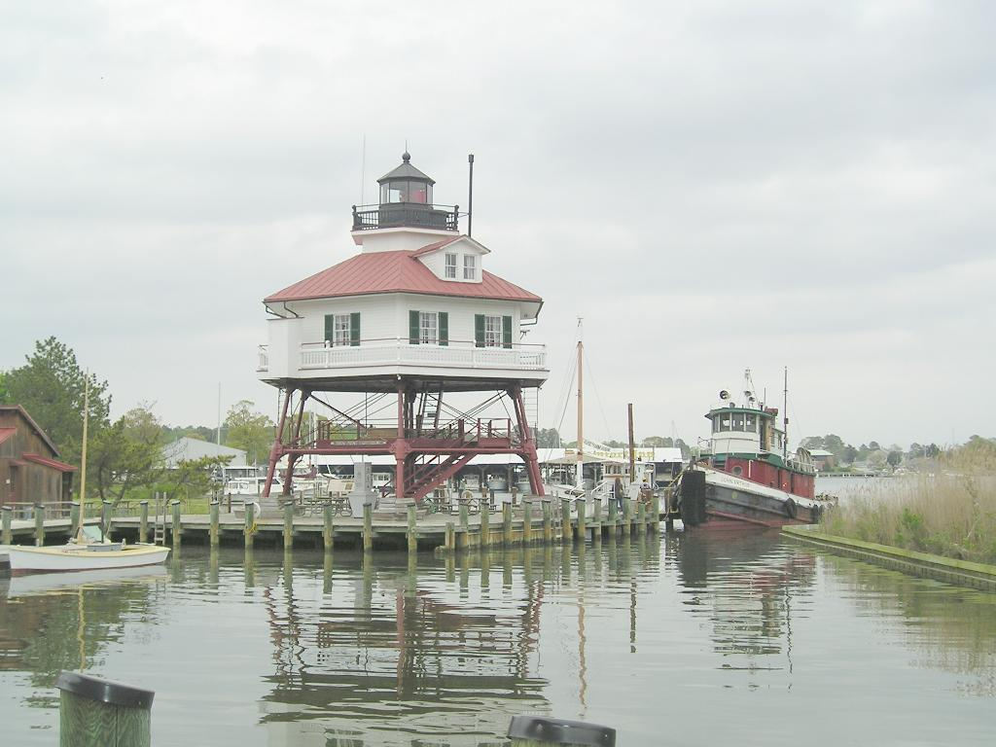
- Port Deposit - Raging on the River
- Baltimore Inner Harbor
- Private Parties
- S/T Baltimore 100th Birthday Parade

